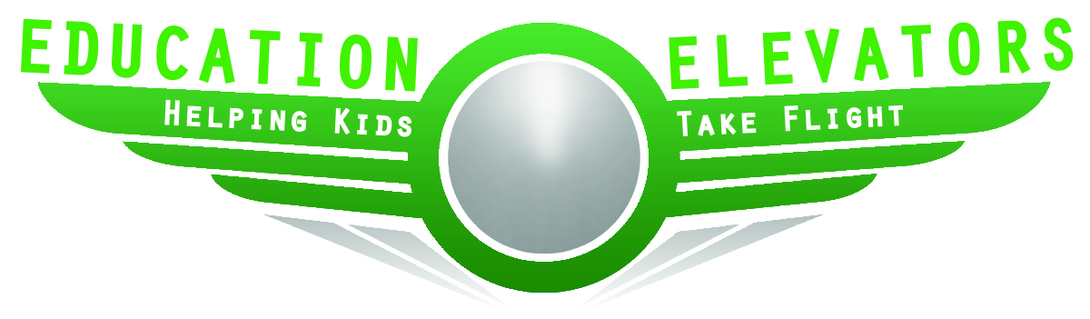
STUDENT AGREEMENT

As a student participating in the Education Elevators Program, I know that there are certain responsibilities and expectations I must maintain to take advantage of the opportunities presented to me through the program.

Therefore, I ________________________________________ agree to the following:

Date: ____________________

_____ I will attend school everyday.

_____ I will complete my classroom/homework assignments on time.

_____ I will seek help if I do not understand the class assignment.

_____ I will respect my parents/guardian, the school staff, my fellow students and my Elevator.

_____ I will continue to believe in myself even when faced with obstacles.

_____ I will always be honest with my Elevator and my teacher.

_____ I will try my best to meet the expectations above.

___________________________________________________________
Student Signature

___________________________________________________________
Elevator Signature

ELEVATOR AGREEMENT

As an Elevator participating in the Education Elevators Program, I know that there are certain responsibilities and expectations I must maintain.

Therefore, I ________________________________________ agree to the following:

Date: ____________________

_____ I will do my best to visit weekly.

_____ I will let my student/teacher know if there is a week I am unable to attend.

_____ I will keep what my student tells me confidential unless I am required to report it to
the guidance counselor.

_____ I will continue to believe in myself even when faced with obstacles.

_____ I will always be honest with my student.

_____ I will try my best to meet the expectations above.

___________________________________________________________
Student Signature

___________________________________________________________
Elevator Signature

